AZURE SUBSCRIPTION VENDING AND ONBOARDING PROCESS DESIGN
Project No.: 24CC3046-P085 | Team No.: T187 | Section: 52-MA

Project Title: “AZURE SUBSCRIPTION VENDING AND ONBOARDING PROCESS DESIGN ”

Mentor: Raju Anitha

Team Members:
2400032180 - Nimmala Mounika
2400032183 - Tirunagari Sai Tejaswi
2400032184 - Bandaru Sai Srija Anuhya
2400032228 - Veluguri SrI Vidhya

SYSTEM ARCHITECTURE :
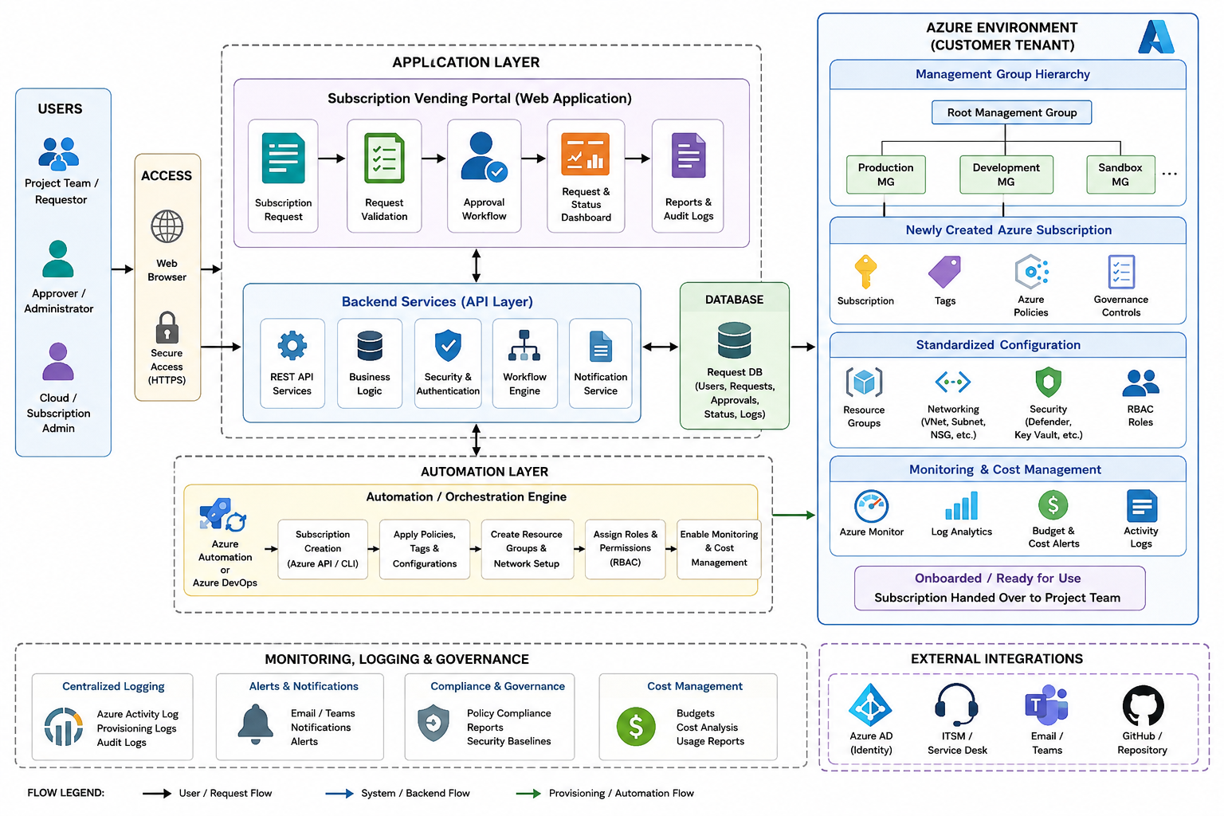

ARCHITECTURE DESCRIPTION:
The proposed system follows a layered architecture consisting of the Application Layer, Automation Layer, Azure Environment, and Monitoring & Governance Layer.
- User Layer: Project teams submit subscription requests, while administrators review and approve or reject the requests.
- Application Layer: The web portal provides subscription request, validation, approval, status tracking, and audit functionalities. The backend APIs handle business logic, authentication, workflow processing, and notifications.
- Database: Stores user details, subscription requests, approval status, provisioning status, and activity logs.
- Automation Layer: After approval, the automation engine provisions and configures the Azure environment using Azure CLI, Azure APIs, or Azure DevOps.
- Azure Environment: The newly provisioned subscription is organized using management groups and configured with resource groups, networking, Azure Policies, security controls, tags, and RBAC permissions.
- Monitoring and Cost Management: Azure Monitor, Activity Logs, and Cost Management are used to monitor resources, maintain logs, configure alerts, and control expenditure.
- Onboarding: After successful validation, the configured subscription is marked as ready and handed over to the respective project team.

Architecture Workflow :
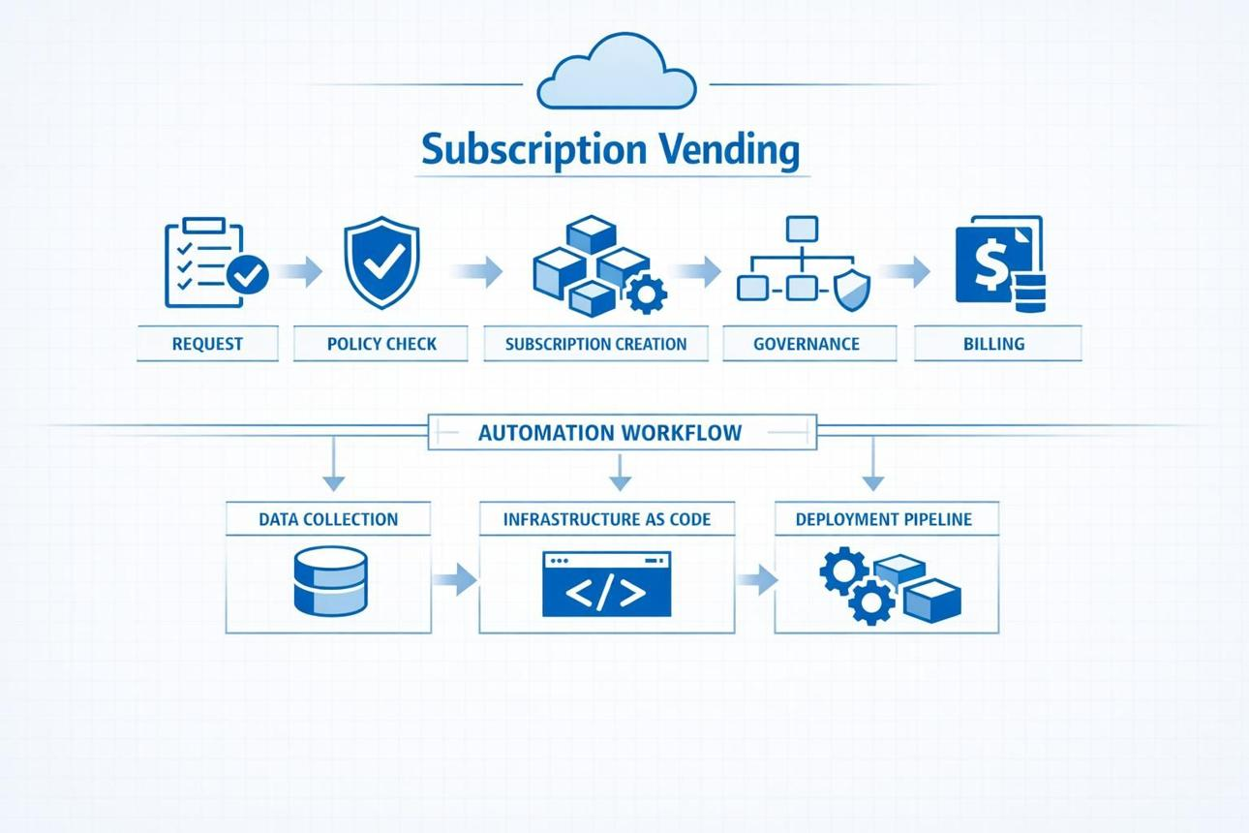
User Request → Validation → Approval → Subscription Provisioning → Policy & Tag Configuration → Resource & Network Setup → RBAC & Security → Monitoring & Cost Management → Validation → Subscription Handover

Technologies Used:
Visual Studio Code, Microsoft Azure Portal, Azure CLI/Azure APIs, Postman/Browser, Git, GitHub, and Database.

